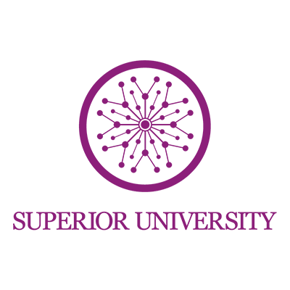
Name : Aiza Noor
Class :BSAI 4C
Subject: Programming of Ai (lab)
Task no: 11

AI Concepts: A Complete Reference Guide
LangChain · LLMs · RAG · FAISS · Vectors · VectorDB · GenAI · GANs

This document explains eight key concepts in the modern AI landscape — what they are, how they differ, and how they connect to each other. From the broad umbrella of Generative AI down to specific tools like FAISS, each concept plays a distinct role in building intelligent systems.
How they fit together: GenAI is the field → LLMs and GANs are two different types of GenAI → LLMs produce Vectors → Vectors are stored in VectorDBs (FAISS is one implementation) → RAG uses a VectorDB to give LLMs real-world knowledge → LangChain is the framework that wires all of this into a working application.
1. Generative AI (GenAI)
The Umbrella Term
Generative AI is the broadest term in this guide. It refers to any AI system capable of creating new content — text, images, audio, video, or code — rather than simply classifying or analyzing existing data.
LLMs and GANs are both types of Generative AI. Think of GenAI as the category name, not a specific technology. When people say 'the GenAI revolution,' they're referring to the explosion of models that can generate human-quality content on demand.

2. LLMs — Large Language Models
The Brain
A Large Language Model is a specific type of Generative AI trained on massive text datasets to understand and generate human language. Examples include GPT-4, Claude, Gemini, and LLaMA.
At their core, LLMs predict the next token (word fragment) in a sequence. This simple mechanism, scaled to billions of parameters and trillions of tokens of training data, enables them to write, summarize, translate, reason, and code.
Key limitation: LLMs have no memory of your private documents or events after their training cutoff. This is exactly the problem that RAG solves.

3. GANs — Generative Adversarial Networks
The Image Generator
GANs are a different type of Generative AI, designed primarily for generating realistic data — especially images. Unlike LLMs, they don't understand language.
A GAN contains two competing neural networks:
• Generator — creates fake data (e.g., synthetic faces)
• Discriminator — tries to detect whether data is real or fake
They train against each other in a feedback loop until the generator becomes so convincing that the discriminator can no longer tell the difference. GANs are used for deepfakes, art generation, data augmentation, and medical imaging.

4. Vectors (Embeddings)
The Language of Meaning
When an LLM processes text, it converts it into a list of numbers called a vector or embedding. This vector captures the semantic meaning of the text in a form that machines can compute with.
For example, the words 'king' and 'queen' will produce numerically similar vectors because they are conceptually close. This is what allows machines to measure meaning and similarity mathematically — not just by matching keywords.
Vectors are the foundational data type that connects LLMs to VectorDBs and RAG pipelines.

5. VectorDB — Vector Database
The Semantic Memory Store
A VectorDB is a specialized database designed to store, index, and search vectors at scale. Unlike a regular SQL database that finds exact keyword matches, a VectorDB finds semantically similar results.
For example, a query like 'What are the side effects of aspirin?' would retrieve documents about aspirin even if they use the phrase 'adverse reactions to acetylsalicylic acid' — because the meaning is similar, even if the words are different.
Popular VectorDBs include Pinecone, Weaviate, Chroma, Milvus, and Qdrant.

6. FAISS — Facebook AI Similarity Search
A VectorDB Implementation
FAISS is a specific open-source library built by Meta (Facebook AI Research) for performing fast similarity searches over large collections of vectors. It is not a full database — it is a highly optimized search engine for vectors.
Think of FAISS as the engine and a VectorDB as the full car. When developers build their own vector search locally, they often use FAISS under the hood. It supports billions of vectors and multiple indexing strategies (flat, IVF, HNSW) optimized for different speed/accuracy trade-offs.

7. RAG — Retrieval-Augmented Generation
The Knowledge Bridge
RAG is a technique that solves one of the biggest LLM limitations: they cannot access your private documents or recent information by default.
RAG works in two steps:
1. Retrieve — search a VectorDB for text chunks relevant to the user's question
2. Generate — feed those chunks into the LLM as context so it can answer based on your actual data
This is how you build a chatbot that 'knows' your company's documentation, a research assistant that answers from your PDFs, or a customer support bot grounded in your product manuals. RAG dramatically reduces hallucinations by anchoring responses in retrieved facts.

8. LangChain
The Orchestration Framework
LangChain is a developer framework — not a model — that makes it easier to build applications using LLMs. It provides ready-made building blocks to chain together LLMs, RAG pipelines, VectorDBs, APIs, memory, and tools.
Instead of writing all the glue code yourself (handling prompt templates, managing conversation history, connecting to VectorDBs, calling external APIs), LangChain gives you a structured way to orchestrate complex AI workflows.
LangChain is the scaffolding that connects all the other pieces. A typical LangChain application might: accept a user question → embed it as a vector → search a VectorDB → inject retrieved context → call an LLM → return a grounded answer.

